My career

Current labels
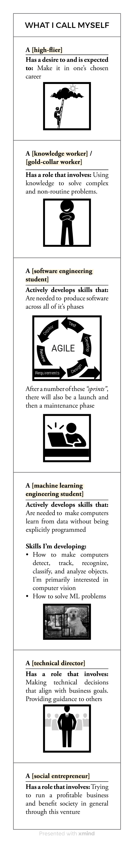

Desired additional labels
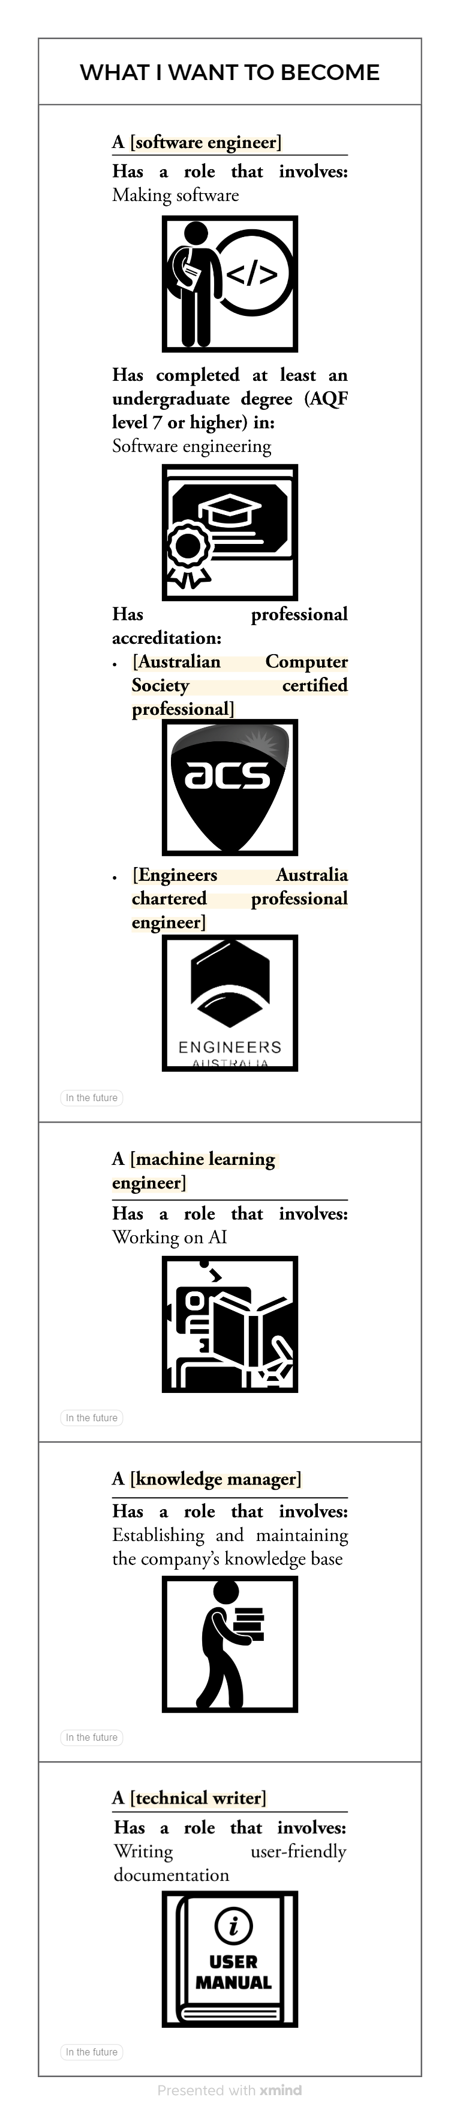
my_career_journey_src.zip

